

**LA GRANDEE INTERNATIONAL COLLEGE**

**Simalchaur, Pokhara Nepal**

“Final Report”

On

**“Leo-Futsal”**

(online booking system)

**Submitted to:**

Bachelor of Computer Application (BCA) Program

In partial fulfilment of the requirements for the degree of BCA under

Pokhara University

**Submitted by:**

|  |  |  |  |
| --- | --- | --- | --- |
| **Name:** | **Course** | **Semester** | **P.U. Registration Number** |
| Kshitij Gurung | BCA | 8th | 2019-01-53-0135 |
| Manish Shrestha | BCA | 8th | 2019-01-53-0120 |
| Kushal Kapri | BCA | 8th | 2019-01-53-0118 |

**Date: 28/06/2024**

# ACKNOWLEDGEMENT

The satisfaction that accompanies after the successful completion of any task will be incomplete without mentioning the people whose ceaseless and relentless cooperation, constant guidance and encouragement made this project possible.

We are grateful to our project supervisor **Mr sunil Sapkota**, and **BCA** coordinator **Mr Ramesh Chalise** for the guidance, inspiration and constructive suggestions that helped us in the preparation of this project.

We are also appreciative among each other and have understood that teamwork, the designation of the task per the skillset one portrays, constant synchronisation and monitoring of progress and instilling new knowledge and skill is imperative for the success of any given work.

Sincerely,

Kshitiz Gurung

Kushal Kapri

Manish Shrestha

**DECLARATION FOR**

**“Leo-Futsal”**

# STUDENT’S DECLARATION

We hereby declare that we are the only authors of this work and that no sources other than the mentioned here have been used in this. We assure you that the work we present here is unique to ourselves and resemblances to another similar project are purely coincidental.

Kshitij Gurung(PU Exam Roll no): 2019-01-53-0135

Manish shrestha (PU Exam Roll no): 2019-01-53-0120

Kushal kapri (PU Exam Roll no): 2019-01-53-0118

Program: BCA, 6th Semester

Date: 28/06/2024

# SUPERVISOR DECLARATION

I hereby recommend that this project entitled “**Leo-Futsal**” is done under my supervision by **Kshitij Gutung** **,Kushal Kapri, Manish Shrestha** during their 8thSemester in partial fulfilment of the requirements for the degree of **BCA** under **Pokhara University** is completed to my satisfaction and be processed for final evaluation.

____________________________

**Name of the Supervisor**

Date:____ / ____ / ________

# LETTER OF APPROVAL

We certify that we have examined this report entitled “**Leo-Futsal**” and are satisfied with the project defence. It is satisfactory in the scope and qualify as project in partial fulfilment of the requirements for the degree of **BCA** under **Pokhara University.**

|  |  |  |
| --- | --- | --- |
| ________________________  **Supervisor**  Mr. Sunil Sapkota | ________________________  **Examiner**  Date:____ / ____ / ________ | ________________________  **Program Coordinator**  Mr. Ramesh Chalise |

# ABSTRACT

The Leo-Futsal will be an online web application based on the principle of providing convenience and service to people. Recently, the online platform is playing an important role in worldwide.The platform improve the customer experience and implement the direct online booking between Organization to customer by implement electronic payments methods. All these plan techniques should be based on deliberated plan according to strategies of electronic payment with the implement the current technology to ensure good revenue.

**Table of Contents**

ACKNOWLEDGEMENT ii

STUDENT’S DECLARATION iii

SUPERVISOR DECLARATION iv

LETTER OF APPROVAL v

ABSTRACT vi

1. INTRODUCTION 1

2. PROBLEM STATEMENT 2

3. OBJECTIVES 3

4. LITERATURE REVIEW 4

5. BACKGROUND STUDY: 5

6.METHODOLOGY 6

7. SYSTEM DESIGN 7

7.1. DATA FLOW DIAGRAM 7

Figure7.1.1:- level 0 DFD 7

Figure 7.1.2:- level 2 DFD user regestration 8

Figure 7.1.3:-level 2 dfd for login user 8

Figure7.1.4:-level 2 DFD for court booking 9

Figure 7.1.5:-level 2 Dfd for payment 10

9. TESTING METHODOLOGY 11

11.PROJECT RESULT 14

12.FUTURE ENHANCEMENT 15

13.CONCLUSION 16

14. REFRENCES 17

15.ANNEX 18

**TABLE OF FIGURE**

Figure 6.1:Agile method………….…….....………………………...6

Figure 7.1.1:Level 0 dfd.………..….………………………………..7

Figure 7.1.2:Level 2 dfd for user regestration……………………….8

Figure 7.1.3:level 2 dfd login user .…….……………………………8

Figure 7.1.4:level 2 dfd court booking.………………………………9

Figure 7.1.5:level 2 dfd payment….…….……………………….…...10

Figure 9.1Database schema:……...…..…….……………………….. 12,13

# INTRODUCTION

Futsal, a fast-paced indoor version of soccer, has become very popular for its focus on skill and teamwork. To make booking futsal courts easier and more convenient, we have developed a mobile app using Flutter. This app ensures a smooth and responsive experience for users looking to reserve futsal courts.

Our backend system, built with Laravel, is designed to reliably manage user reservations, court availability, and interactions with court vendors. We provide real-time updates so users always have the latest information on court availability, helping them make quick and informed booking decisions.

The app is user-friendly and includes features that cater to the needs of futsal players. This ensures that the app not only makes booking easier but also enhances the overall futsal experience.

Leo-Futsal Application Modules:

Here we need totally 2 modules. They are,

User

Admin

1. User – Actually User can book the Futsal and do payment with khalti.

2. Admin – Admin have full access permission who manages all the details like order-venue, update Application, manage users.

Technology used:

Front-End : Fluter

Back-End : PHP

Database : MySQL

Editor : Visual Studio Code IDE

# PROBLEM STATEMENT

There can be several problem statements that led to the development of the mobile application, some of which are:

1. Data Security: Mobile Application platforms handle sensitive customer data such as personal and payment information, making them a target for cyber-attacks and data breaches. Ensuring the security of Andriod Application platforms is critical for protecting customer data and maintaining trust. So, Customer’s data security is the main existing problem for today’s Andriod Applicatioin platforms, which we could handle.
2. **Inefficient Booking Systems**: Existing futsal court booking systems are often cumbersome and lack user-friendly interfaces, making the reservation process difficult and time-consuming.
3. **User Dissatisfaction**: Due to the above issues, users face difficulties in organizing and enjoying their futsal games, leading to overall dissatisfaction with the booking process.

Addressing these challenges and problems requires careful planning, investment in technology and resources, and ongoing maintenance and improvement of the mobile application platform.

# OBJECTIVES

Following are the objectives of the Leo-Futsal:

* Dynamic Mobile App: Use Flutter to build a responsive app that prioritizes a seamless user experience for easy futsal court reservations.
* Robust Backend System: Using Laravel, create a dependable backend architecture to effectively manage user reservations, court availability, and vendor interactions.
* Real-Time Updates: Make sure users have accurate information to make well-informed booking selections by providing them with up-to-date information about court availability.
* User-Centric Features: Align the app with the requirements and preferences of the user by introducing amenities selection, team development, and in-app communication.

# LITERATURE REVIEW

Andriod application are entirely towards every developed and developing country.it can be accomplished and can make a remarkable benefits to developing countries. It also an ideal business purpose can be made.

Many top authors clearly discuss that e commerce is the revolution and turning point in online business and can make a huge contribution to the economy. The famous author Hassan also indicated that currently mobile application have increasingly become a fundamental components of business strategy and a strong catalyst for economic development. A huge number of research done on a application which is basically on online booking .A large group of researchers has found out and also pointed out the necessity and possibilities of mobile application.

Literature review method is applied to analye the role of Application in online booking activities as well to provide the improvement for future researches. As many as Andriod application related literature are analysed comprehensively and systematically based on protocol review. The result of research confirm the oppurtunitues for future research on application system at enable the integration on business processes.the supporting variable of application include the business branding , social and economic development, inficient system application platform,framework application.study by tarafadar and Vaidya examined the factors the organizational incilation to adopt android application.

# 5. BACKGROUND STUDY:

Our team engaged in extensive discussions to determine an ideal project topic. One of our members proposed the idea of developing an Android application for futsal court reservations, which we named Leo Futsal. After conducting thorough research, we concluded that this topic was well-suited for our first project due to its simplicity and high usability in real life. We recognized that futsal is gaining popularity as a sport, and there is a growing need for efficient and user-friendly court booking systems.

The concept of reserving sports facilities, such as futsal courts, has evolved significantly over time. Traditionally, booking a court involved cumbersome processes, often requiring phone calls or in-person visits, which were prone to errors and double bookings. This method was inefficient and did not provide users with real-time information about court availability, leading to frustration and inconvenience.

With the advent of digital technology and mobile applications, these traditional methods have become outdated. The development of e-commerce and online booking systems has paved the way for more streamlined and accessible solutions. E-commerce itself originated from the need to exchange business documents electronically, which eventually evolved into comprehensive online transaction systems. Similarly, the need for efficient management of sports facility bookings has driven the development of specialized applications.

In today's digital era, mobile applications are indispensable tools for managing various aspects of life, including sports reservations. A futsal court booking app like Leo Futsal can revolutionize the way players reserve courts, offering them convenience, real-time updates, and a host of user-centric features. By using modern technologies like Flutter for the front end and Laravel for the backend, we aim to create a responsive and reliable platform that caters to the needs of futsal enthusiasts.

The development of Leo Futsal is inspired by the evolution of e-commerce and online transaction systems. Just as e-commerce has simplified and enhanced the shopping experience by providing a vast array of products and services in one place, our app aims to simplify futsal court reservations by offering a comprehensive solution that includes real-time updates, amenities selection, team management, and in-app communication.

In conclusion, Leo Futsal is designed to replace traditional court booking methods with a modern, efficient, and user-friendly Android application. This project not only addresses the growing demand for futsal court reservations but also leverages the advancements in digital technology to provide a superior user experience.

# 6.METHODOLOGY

Our application development methodology will be the agile methodology, which will emphasizes flexibility and collaboration between the development team and the client.

In the Agile methodology, the development process will be divided into short iterations or sprints, typically lasting 1-4 weeks. Each sprint includes planning, design, development, testing, and feedback phases. The development team works closely with the client throughout the entire process, with frequent communication to ensure that the project is on track and meets the client's needs.

Actually, our software development methodology will be based on Agile as this methodology embraces change and allows for flexibility throughout the development process. It accommodates evolving requirements, new insights, and market demands, enabling teams to respond quickly to changes without disrupting the entire project. This adaptability helps in delivering a product that better aligns with customer needs. Agile places a strong emphasis on customer collaboration and involvement. It encourages regular communication between the development team and the customer to gather feedback and understand their evolving requirements.

. 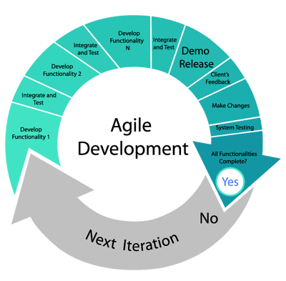

**. Figure 6.1: Agile methodology development**

# 7. SYSTEM DESIGN

# 7.1. DATA FLOW DIAGRAM

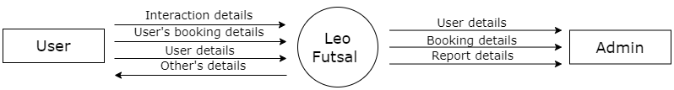DFD stands for Data Flow Diagram, which is a graphical representation of a system or process that shows the flow of data between different components of the system. It is a useful tool for analysing and designing complex systems, and it can help to identify potential problems and inefficiencies in a system.

# Figure7.1.1:- level 0 DFD

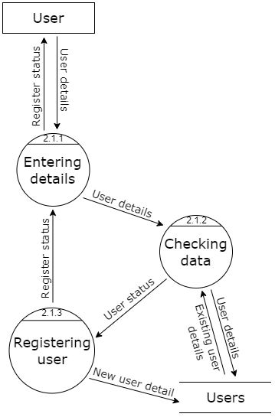

# Figure 7.1.2:- level 2 DFD user regestration

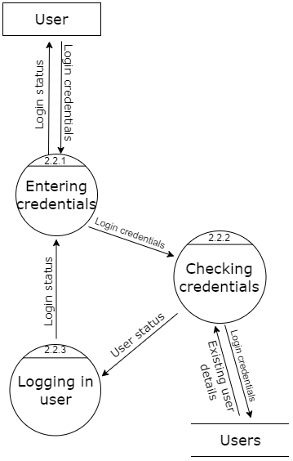

# Figure 7.1.3:-level 2 dfd for login user

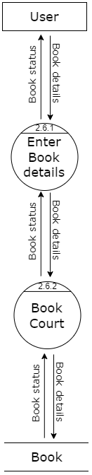

# Figure7.1.4:-level 2 DFD for court booking

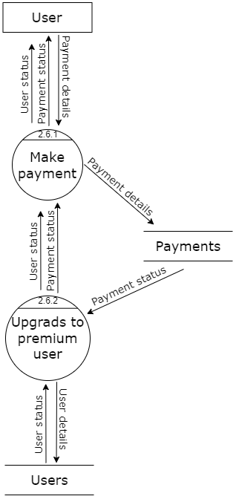

# Figure 7.1.5:-level 2 Dfd for payment

# 9. TESTING METHODOLOGY

Testing methodology is the various strategy or approaches used to test and application to ensure it behaves and looks as expected.the method or approaches to testing that include unit testing through system testing.It also include testing lifecycle.

|  |  |  |  |  |
| --- | --- | --- | --- | --- |
| Test Case ID | Test Case | Test Steps | Test Data | Results |
| TC001 | Applicatioin login | 1. Open the application   And navigate to login page | User name password | Login successfully. |
| TC002 | Registration | 1. Navigate to signup page 2. Enter the full name, email,contact numberand password 3. Click on the signup | Full name, email,password and signup | Signup successfully  . |
| TC003 | Venu booking | 1. Opean the selected futsal | Select the time  The register the booking | Venu booking succesfully |
| TC004 | Payment | 1. Opean and navigate to khalti scrren | Login  Amount  otp | payment  successfully |
| TC005 |  | 1).login to admin panel  2). Select time and do payment it will be register in histry. |  | Done successfully |
| TC006 | Register new account | 1. Open the Application and search leo-futsal 2. Press the user icon 3. Click on register signup 4. Insert username, email , password | Username:maish  Email:manish@anish.com  Password:mainsh  Conform password:  manish | Register successful |

# 11.PROJECT RESULT

The Leo Futsal project will significantly improve the process of booking futsal courts by leveraging modern technology to deliver a user-friendly and efficient solution. The key outcomes will include:

* **Improved User Experience**: A well-designed app that simplifies the booking process and provides real-time updates will enhance user satisfaction and retention.
* **Operational Efficiency**: A dependable backend system will streamline operations for court managers and vendors, reducing administrative burdens and improving service quality.
* **Enhanced Community Engagement**: Features that support team development and communication will help build a vibrant futsal community, encouraging more players to participate and stay engaged.
* **Increased Adoption**: The comprehensive and user-centric design of the app will attract a wide user base, promoting the adoption of digital solutions for futsal reservations and potentially expanding to other sports facilities in the future.

Overall, the Leo Futsal project will set a new benchmark for sports facility booking systems, providing a modern, efficient, and enjoyable experience for users and court managers alike.

# 12.FUTURE ENHANCEMENT

**Advanced Payment Options**: Incorporate more payment methods including digital wallets, cryptocurrencies, and installment payment plans. This flexibility will enhance the user experience and cater to diverse user preferences

**Enhanced Social Features**: Develop more social features such as player profiles, match history tracking, and social media integration. This will help users showcase their achievements, share their experiences, and connect with other players more easily.

**Analytics and Insights for Vendors**: Provide detailed analytics and insights to court owners and vendors, helping them understand user behavior, peak times, and preferences. This data can assist in optimizing court management and improving services.

**Multi-Sport Facility Booking**: Expand the app to include reservations for other sports facilities such as basketball courts, tennis courts, and swimming pools. This will attract a wider user base and increase the app's utility.

# 13.CONCLUSION

In conclusion, the development of Leo Futsal marks a significant advancement in simplifying and enhancing the reservation process for futsal enthusiasts. Our team's dedication to leveraging modern technologies like Flutter for the frontend and Laravel for the backend has resulted in a mobile application that prioritizes user experience and functionality. Leo Futsal not only streamlines the booking of futsal courts but also ensures a seamless and intuitive journey for users, from finding available courts to selecting amenities and managing teams.

The app's robust backend architecture guarantees efficient management of user reservations, court availability, and vendor interactions. Real-time updates play a crucial role in providing users with accurate information, enabling informed booking decisions and minimizing scheduling conflicts. Moreover, Leo Futsal's user-centric features such as amenities selection and in-app communication foster community engagement and cater to the diverse needs of players, enhancing overall satisfaction and usability.

Looking forward, Leo Futsal has the potential to expand its impact by incorporating future enhancements such as AI-driven recommendations, multi-sport facility bookings, and advanced social features. These developments aim to further enrich the user experience, broaden the app's utility across different sports, and strengthen community bonds within the futsal community. As we continue to innovate and refine Leo Futsal, our goal remains steadfast: to provide a reliable, efficient, and enjoyable platform that meets the evolving needs of sports enthusiasts and enhances their experience in reserving sports facilities.

# 14. REFRENCES

**ChatGPT - OpenAI:https://openai.com/research/chatgpt/**

**YouTube – Andriod developmen Tutorials:** [**https://www.youtube.com/playlist?list=PL4cUxeGkcC9g9gP2onazU5-2M-AzA8eBw**](https://www.youtube.com/playlist?list=PL4cUxeGkcC9g9gP2onazU5-2M-AzA8eBw)

**Design - Interaction Design Foundation:** [**https://www.interaction-design.org/literature/topics/ux-design**](https://www.interaction-design.org/literature/topics/ux-design)

# 15.ANNEX